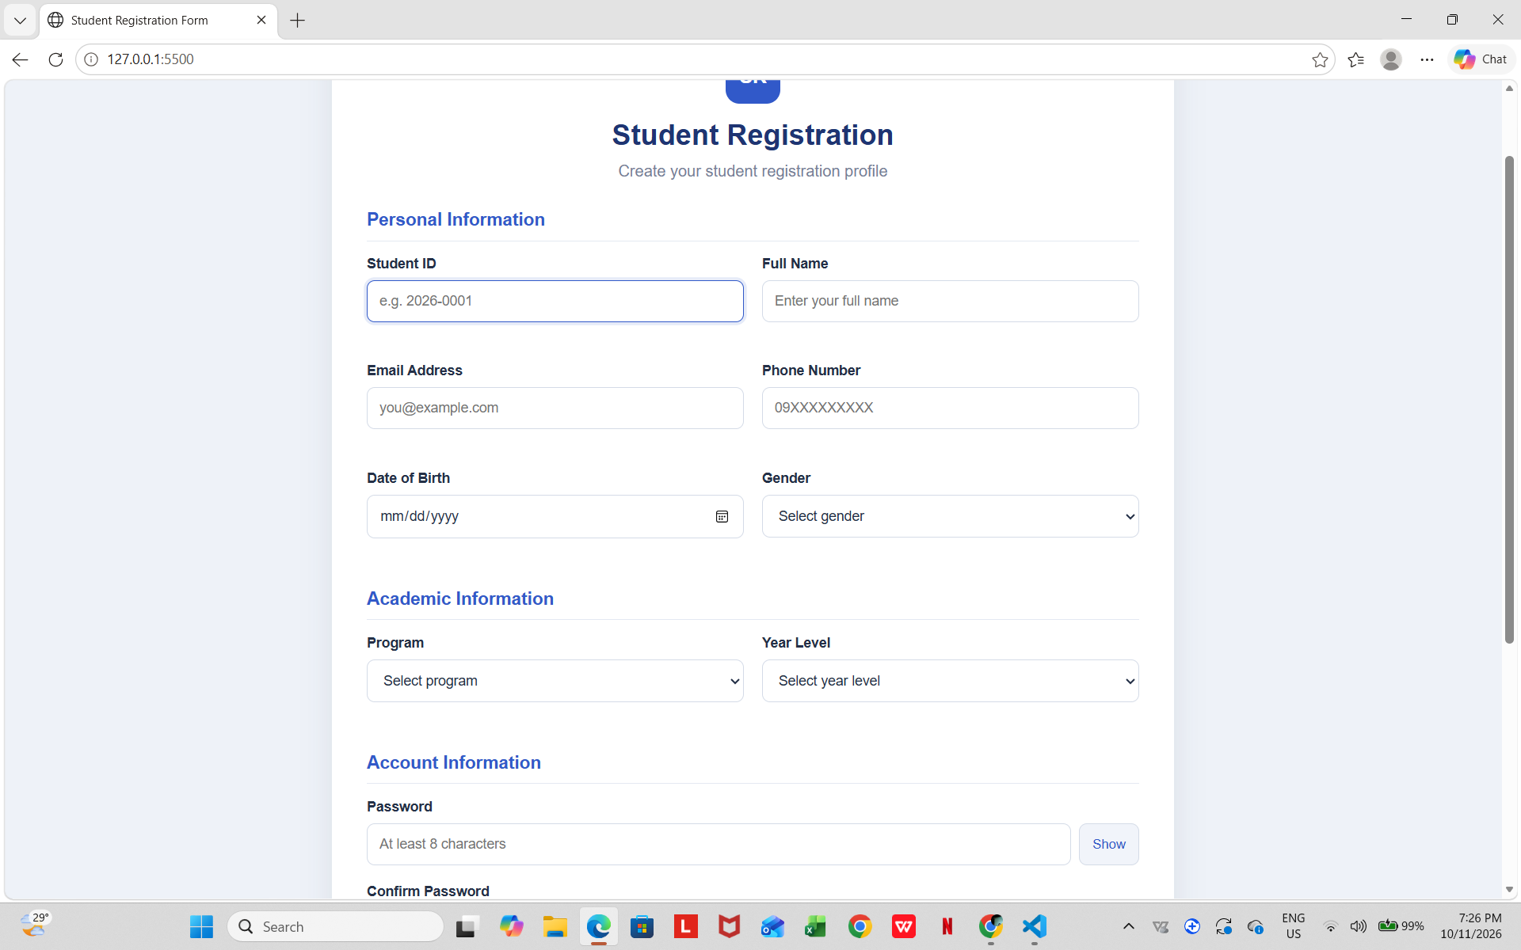
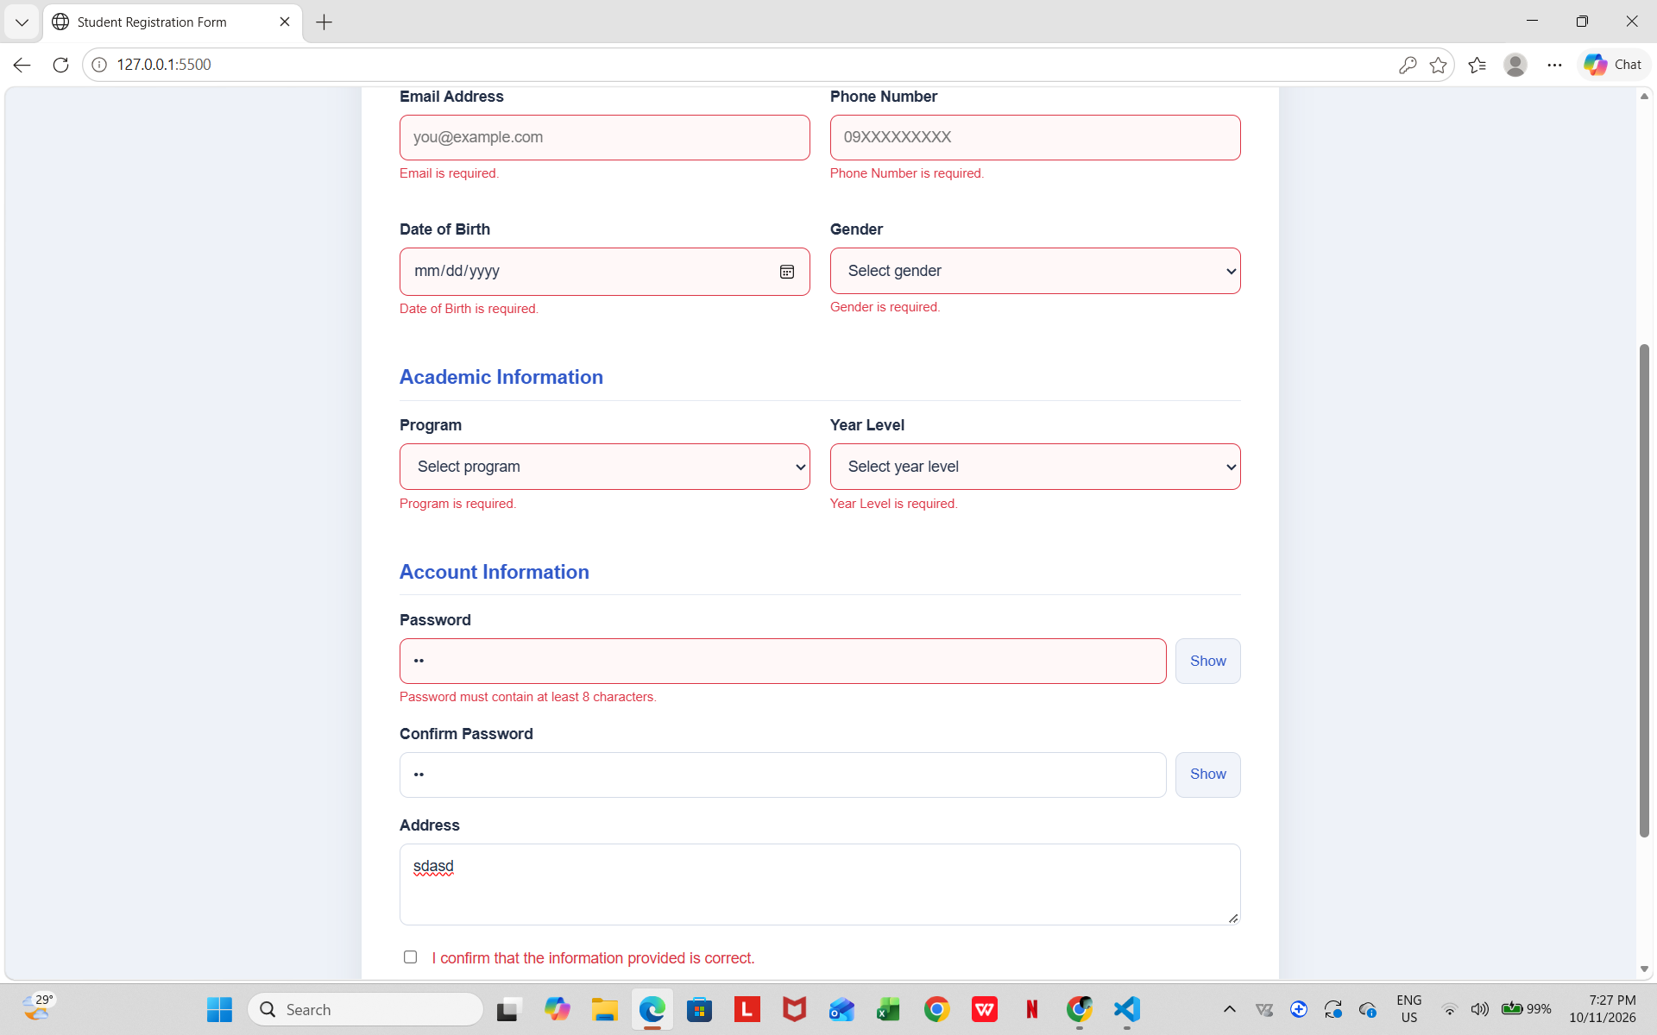
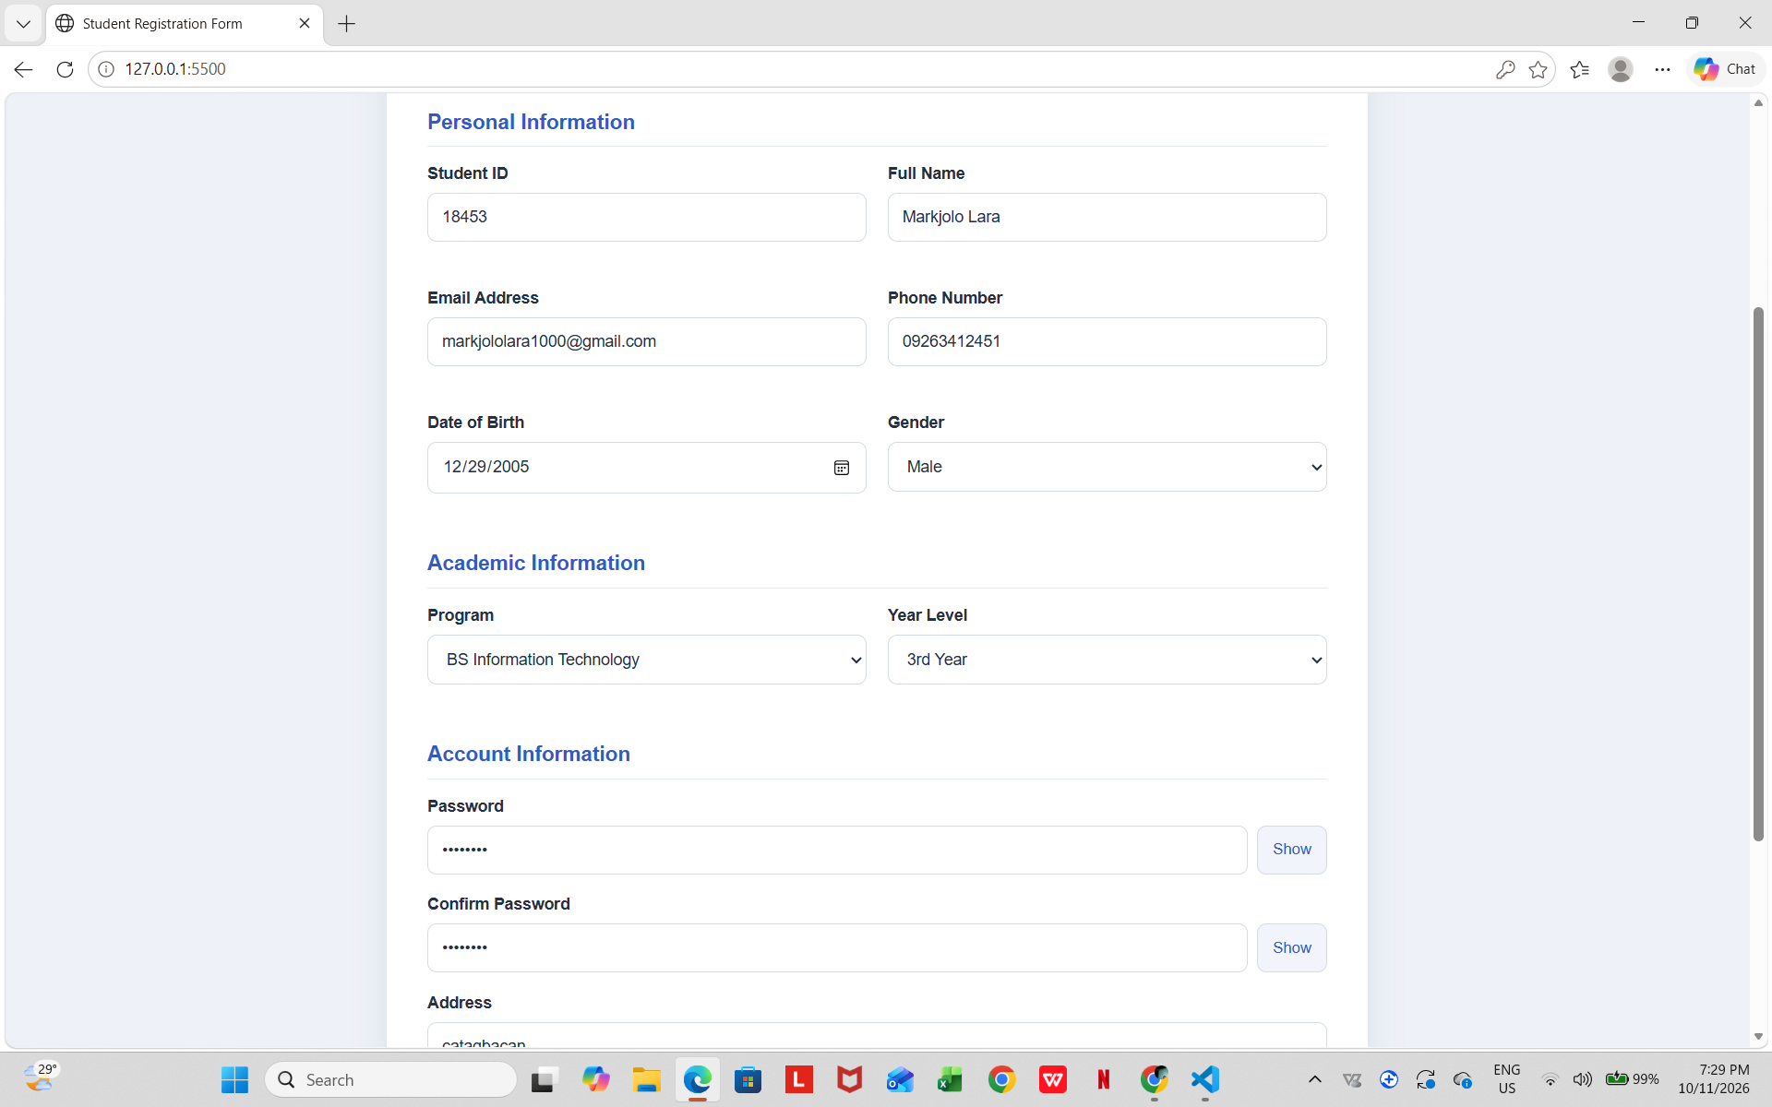
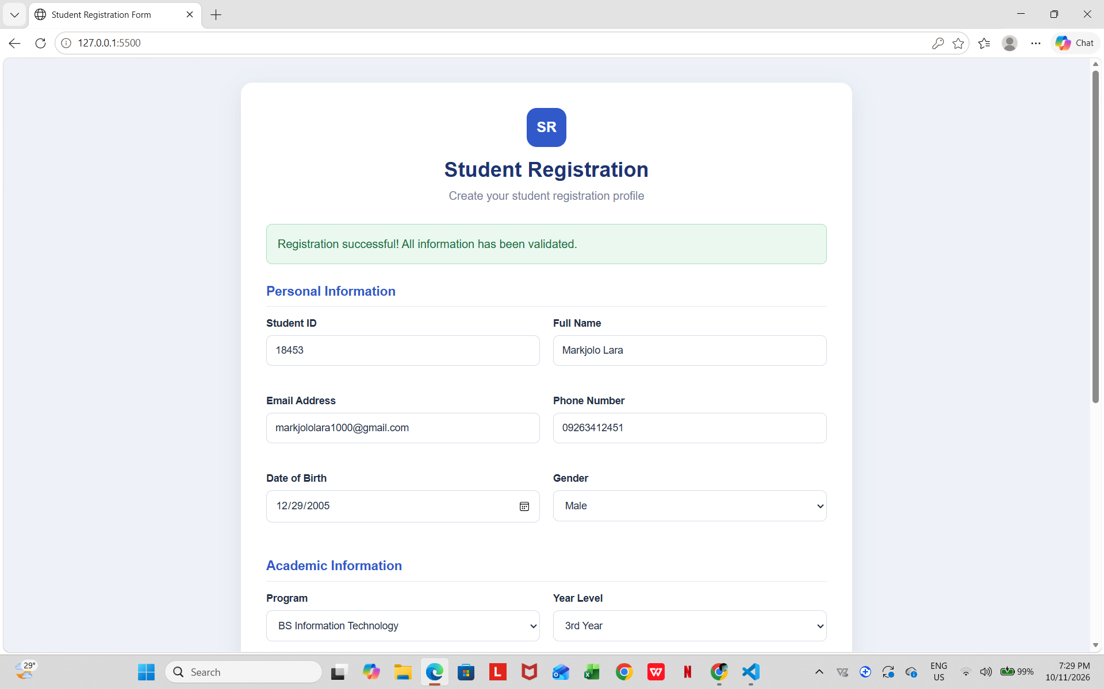
- JavaScript validates the required fields, removes unnecessary spaces using trim(), checks the email format and Philippine phone number format, and verifies that the password and confirmation password match.

- The form uses addEventListener("submit", function(event) {...}) to handle submission and event.preventDefault() to prevent the page from submitting before validation is completed.

- Each invalid field displays a specific error message to help the user correct the information.

- The classList.add() and classList.remove() methods apply and remove the error styling when fields are invalid or corrected.

- The classList.toggle() method changes the appearance of the Show/Hide Password buttons when the user clicks them.

- Custom data-label, data-required, and data-target attributes store field labels, required-field information, and password input IDs, which JavaScript accesses using dataset.
- JavaScript dynamically changes the password input's type attribute between password and text to hide or display the password.

- When all required information is valid and the agreement checkbox is selected, the form displays a registration success message.
- The Reset Form button clears the entered information, error messages, error styling, and success message, returning the form to its initial state.

